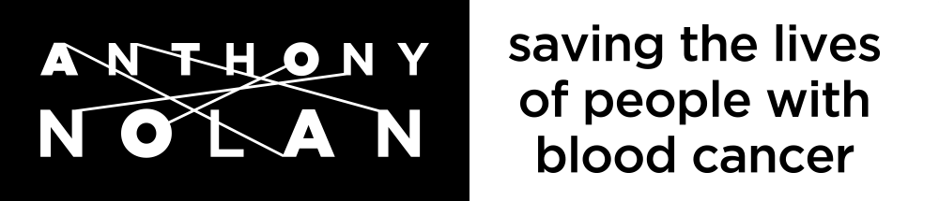
Christmas Raffle 2021 Rules, Terms & Conditions
- These terms and conditions set out the Rules for the Anthony Nolan Christmas Raffle 2021. By purchasing a raffle entry, a player agrees to be bound by these Rules.
- Applications must be from players aged 18 years old or over. No person under this age is allowed by law to enter the Anthony Nolan Christmas Raffle 2021.
- We are only able to accept debit card payments for raffle tickets purchased on the website or over the phone. You are still able to enter the raffle using a credit card, debit card or cheque by post.
- The closing date of the Anthony Nolan Christmas Raffle 2021 is Thursday 09 December 2021 at 11.59pm and any money received after 11.59pm on Thursday 09 December 2021 will be treated as donations.
- The draw will take place on Thursday 16 December 2021. Winners will be notified as soon as possible by telephone or in writing and within 2 weeks of the draw.
- All reasonable efforts will be made to contact prize winners, but if Anthony Nolan cannot contact a winner, Anthony Nolan reserves the right to distribute the prize as appropriate. All prizes must be claimed within 28-day period of the draw. Anthony Nolan reserves the right to request proof of identity and age from any person who claims a prize.
- All prize payments shall only be made electronically via BACS transfer.
- Anthony Nolan reserves the right without notice or reason to cancel or refuse entry to the raffle. Anthony Nolan's decision on all matters affecting the draw is final and legally binding. No correspondence regarding the results of the draw will be entered into.
- The raffle is being managed on behalf of Anthony Nolan by The Woods Group Limited (company number 03665861), which is acting as external lottery manager on behalf of Anthony Nolan. The Woods Group is licensed by the Gambling Commission (with licence numbers 000-003586-N-103664-010 (Non-Remote) and 000-003586-R-310429-007 (Remote)).
- Complaints will be handled in line with the complaints procedure found within Anthony Nolan's FAQ's page. Complaints that cannot be resolved by Anthony Nolan, with assistance from the Woods Group, will be escalated to The Independent Betting Adjudication Service Ltd (IBAS).
- The winners of the Anthony Nolan Christmas Raffle 2021 will be notified by telephone where a telephone number is available and by post if no telephone number is provided. A list of winners will be published on our website https://anthonynolan.org/help-save-a-life/donate-money/anthony-nolan-raffle after the draw.
- The cost of each ticket and entry is £1.
- The maximum number of tickets per person is 100.
- There are 8 prizes available.
- There is one prize of £5,000, one prize of £1,000 and £500, plus five runner up prizes of £50 each. There are no prize alternatives and no interest is payable.
- Prizes are drawn at random, with the first ticket drawn being allocated the first prize, the second ticket drawn being allocated the second prize, and so on.
- For a single ticket entered, the likelihood of winning a prize is estimated to be 1 in 3,860.
- All warranties, conditions and guarantees relating to the raffle by or on behalf of Anthony Nolan or The Woods Group Limited, whether express or implied by law are excluded to the maximum extent permitted by law.
- The liability of Anthony Nolan and The Woods Group Limited to any player shall be limited to the amount of any prize which is due to that person.
- No liability is accepted for loss, theft or delay due to postal delays.
- Tickets may not be sold in the street.
- Anthony Nolan staff, trustees and their families are excluded from playing all Anthony Nolan raffles and lotteries, including the Anthony Nolan Christmas Raffle 2021. Volunteers may participate in raffles and lotteries unless they are involved in the administration of that raffle/lottery in which case they must not participate. This also applies to the volunteer's immediate family. Woods Group employees are excluded from playing any raffles or lotteries which Woods Group promotes, including the Anthony Nolan Christmas Raffle 2021.
- This raffle has been printed and produced by the Woods Group and all response handling activities are being externally managed on behalf of Anthony Nolan by the Woods Group.
- No detail in a raffle entry may be changed in any way once it has been submitted except for change of address.
- All information provided by players for the purposes of the raffle will be stored, managed and used in accordance with data protection law and the Anthony Nolan Privacy Policy, which is available here: https://www.anthonynolan.org/privacy-policy.
- Anthony Nolan will not transfer or otherwise disclose the personal data of any player to any third party, except the Gambling Commission, law enforcement agencies or in any other circumstances where required by law.
- Anthony Nolan reserves the right to update the Raffle Rules, Terms & Conditions and any updated version will be effective as soon as it is published on the website: https://www.raffleentry.org.uk/Anthonynolan/rules
- The Anthony Nolan Christmas Raffle 2021 is open to residents of England, Wales and Scotland. No entrants are allowed to enter the raffle from Northern Ireland, the Channel Islands, the Isle of Man or British Forces Post Office addresses.
- The Anthony Nolan Christmas Raffle 2021 is subject to the laws of England and Wales.
- In financial year 2020/21 £38,500 was raised from ticket sales in our raffles, with 18% spent on prizes, 28% re-invested into growing the gaming programme so it can raise even more in the future, and 54% being used to further Anthony Nolan’s charitable objectives.

Supporting information used in promotion of Anthony Nolan Christmas Raffle 2021.
Anthony Nolan is licensed by the Gambling Commission, licence numbers 000-003586-N-103664-010 (Non-Remote) and 000-003586-R-310429-007 (Remote) and this raffle is run under the rules laid down by the Gambling Act 2005.
The Anthony Nolan Christmas Raffle 2021 is intended to be a fun way to support Anthony Nolan and the vital work we do. Are you gambling more than you really want to? If you feel you have a problem with gambling please visit GambleAware's website for help and advice, or contact the National Gambling Helpline between 8 am and midnight on 0808 8020 133. To exclude yourself from our database for future raffle mailings please contact: support@anthonynolan.org
Anthony Nolan is a member of the Lotteries Council www.lotteriescouncil.org.uk and therefore supports and contributes to research into problem gambling.
The person responsible for the promotion of this lottery is Jo Mazur, Head of Individual Giving, Anthony Nolan, Head Office, 2 Heathgate Place, 75-87 Agincourt Road, London, NW3 2NU. Registered charity numbers: 803716/SC038827
For more information about Anthony Nolan, our raffles and other ways to donate please visit https://www.anthonynolan.org/ or contact our supporter care team by email at support@anthonynolan.org or by calling 020 7424 6626.

